

Provisioning Guide for Lync-Skype Connectivity

Microsoft Lync Server 2013 and Lync Online
Published: May 2013
This document is provided “as-is”. Information and views expressed in this document, including URL and other Internet Web site references, may change without notice.
Some examples depicted herein are provided for illustration only and are fictitious. No real association or connection is intended or should be inferred.
This document does not provide you with any legal rights to any intellectual property in any Microsoft product. You may copy and use this document for your internal, reference purposes.
Copyright © 2012 Microsoft Corporation. All rights reserved.

Contents
Provisioning Guide for Lync-Skype Connectivity 5
Enabling Lync - Skype Connectivity for Office 365 and Lync Online 5
Overview of Lync-Skype Connectivity Process for Lync Server 5
Accessing the Microsoft Lync Server Public IM Connectivity Provisioning Site 6
Enabling Federation and Public IM Connectivity (PIC) 7
Using Lync-Skype Connectivity as an End User 10

Provisioning Guide for Lync-Skype Connectivity

Enabling Lync - Skype Connectivity for Office 365 and Lync Online
If you have Office 365 Midsized Business or Enterprise, sign in to Office 365 and then open the Lync Online Control Panel. Go to External communications and under Public IM Service Providers, click Enable. If you want to control individual user access to Lync-Skype Connectivity, you can edit individual users’ External communication settings.
If you have Office 365 Small Business Premium, sign in to Office 365, and go to Admin > Service Settings > Instant messaging, meetings and conferencing. Turn on External communications.
Note:
The External communications switch in Office 365 Small Business Premium turns on both Lync-Skype Connectivity and communications with other organizations that use Lync. Depending on when you started using Lync Online, the External communications switch may appear On but with Lync-Skype Connectivity actually turned off. You can toggle the switch Off and back On again to turn both on.
Overview of Lync-Skype Connectivity Process for Lync Server
Lync Server supports connectivity with Skype. This connectivity allows Skype users and Lync users to add each other as contacts, exchange instant messages and make audio calls. Skype connectivity allows your Lync Server users to add Skype contacts using the Skype user’s Microsoft Account (MSA). Skype clients can add Lync users to their contact list. Based on policies administratively set in Lync Server, Lync and Skype users will be able to communicate using instant messaging, see each other’s presence, and initiate audio calls.

The remaining topics in this document describe the steps for Lync-Skype connectivity. They include:
• Accessing the Microsoft Lync Server Public IM Connectivity Provisioning Site
• Enabling Federation and Public IM Connectivity (PIC)
• Using Lync-Skype Connectivity as an End User

Important:
If Lync Server was already configured to connect with Windows Messenger using public IM connectivity (PIC), your deployment is already configured for Lync- Skype connectivity. The only change you may want to consider is to rename your existing Messenger PIC entry to be Skype. For details, see Configure the Skype PIC provider setting for Lync topic, later in this document.
Accessing the Microsoft Lync Server Public IM Connectivity Provisioning Site
The provisioning process for Lync - Skype connectivity has changed, as compared to previous PIC provisioning methods. The Lync - Skype provisioning process can take up to thirty days to complete. It is recommended that you start this process first, prior to completing the remaining steps in this document. After the Lync - Skype provisioning process is completed for your account, the account is activated and your eligible users are enabled for public IM connectivity.

To provision Lync - Skype connectivity, you need the following information:
1. Microsoft Agreement Number
2. Access Edge service fully qualified domain name (FQDN)
3. Session Initiation Protocol (SIP) domain(s)
4. Any additional Access Edge service FQDNs
5. Contact information
To initiate the provisioning process for Lync - Skype connectivity:
1. Sign in to the website, https://pic.lync.com, using your Microsoft Windows Live ID.
2. Select the Microsoft licensing agreement type.
3. Check the box verifying that you have read and accept the Product Use Rights for Lync Server.
4. On the Initiate a Provisioning Request page, click the appropriate link to initiate a provisioning request:

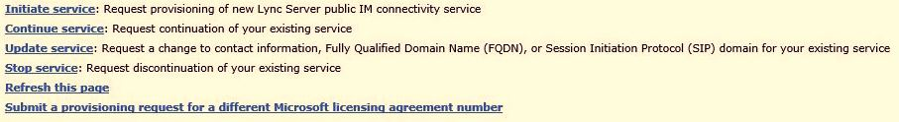

5. On the Specify Provisioning Information page, enter the Access Edge service FQDN. For example, accessedge.contoso.com.
6. Enter at least one or more SIP domain names, and click Add.

Important:
At least one Access Edge server and one SIP domain are required to complete the provisioning process. The SIP domain and the Access Edge server must be active, functioning and reachable on the network.
7. In the list of Public IM Service providers, select Skype and click Next to add Contact information, and submit the provisioning request.
Once the provisioning request has been submitted, it can take up to 30 days for the account to activate and users are enabled for public IM connectivity.
Enabling Federation and Public IM Connectivity (PIC)
Now that the provisioning request has been submitted, it is now time to focus on the Lync Server environment and administrative tasks required to configure Lync - Skype connectivity. In this section, we assume that the Lync Server administrator has deployed Lync Server and configured external access. For additional information on configuring external access for Lync Server, see the topics Planning for External User Access and Deploying External User Access in the Lync Server documentation.

To prepare the Lync Server environment for Lync - Skype connectivity, the Lync Server administrator must complete the following three tasks:
1. Configure federation and PIC
Federation is required to enable Skype users to communicate with Lync users in your organization. Public Instant Messaging Connectivity (PIC) is a class of federation, and must also be configured to allow your Lync users to communicate with Skype users. Federation and PIC are configured using the Lync Server Control Panel, shown below.

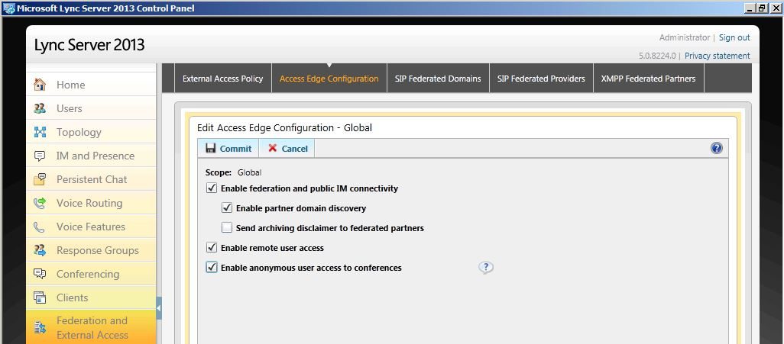

Important:
PIC federation is no longer supported with Live Communication Server 2005 SP1 or Office Communications Server 2007. The supported platforms for PIC federation include Lync Server 2013, Lync Server 2010, and Office Communications Server 2007 R2.

2. Configure at least one policy to support federated user access
Using the Lync Server Control Panel, an administrator must configure one or more external user access policies to control whether Skype users can collaborate with internal Lync Server users.

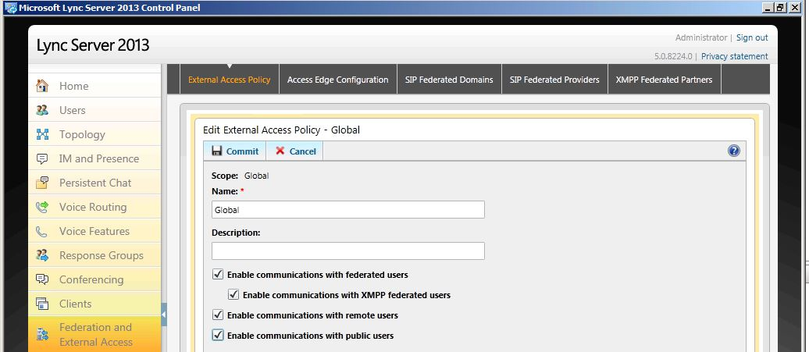

3. Configure the Skype PIC provider setting for Lync
Using the Lync Server Management Shell, an administrator must configure the Lync client policy to display Skype as an additional PIC provider.

Note:
Users of Public Instant Messaging Connectivity (PIC) service providers cannot participate in IM or conferences in your organization until you also configure at least one policy (step 2 above) to support public IM connectivity.

To prepare the Lync Server environment for Lync - Skype connectivity, do the following:
1. To configure federation and PIC, see To enable or disable federated user access for your organization.
2. To configure at least one policy to support federated user access, see To configure an external access policy to support public user access.

To edit a Messenger PIC provider and configure it for Skype, do the following:
1. From a Lync Server Front End Server, open the Lync Server Management Shell.
2. Run the following two commands:

Remove-CsPublicProvider -Identity Messenger
New-CsPublicProvider -Identity Skype -ProxyFqdn federation.messenger.msn.com -IconUrl "https://images.edge.messenger.live.com/Messenger_16x16.png" -VerificationLevel 2 -Enabled 1

3. From a Lync client, you can now select Skype as the PIC provider, and add a Skype client by specifying their MSA account. For additional information on adding clients to Lync, see the topic Using Lync-Skype Connectivity as an End User.

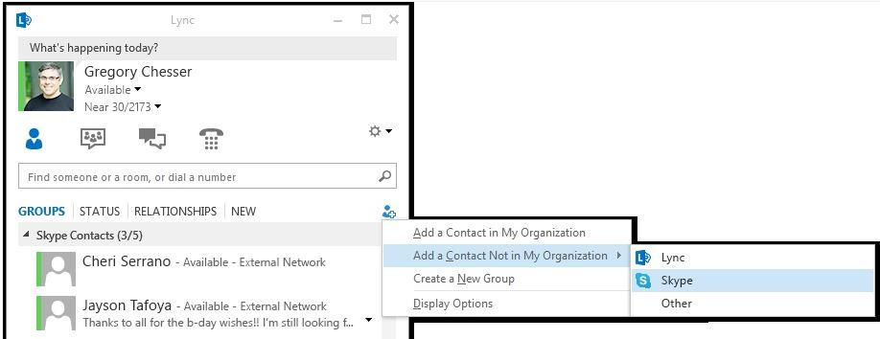

4. For detailed information on modifying hosted providers, see Create or Edit Hosted SIP Federated Providers.

Congratulations! You are now setup for Lync-Skype connectivity. This completes the administrative tasks that must be performed on the server. In the next topic, we focus on tips for using Lync-Skype connectivity as an End-User.
Using Lync-Skype Connectivity as an End User
Lync - Skype Connectivity allows Skype users and Lync users to add each other as contacts, exchange instant messages and make audio calls. When a Skype user adds a Lync user, a Skype user will create a contact in Skype containing the session initiation protocol (SIP) uniform resource identifier (URI) of the Lync user. Conversely, when a Lync user adds a Skype contact, the Lync user will create a contact in Lync that will contain the Microsoft Account (MSA) of the Skype user, and not the Skype user name.
What is an MSA? Skype users must sign in to Skype with a Microsoft account (previously called Windows Live ID) in order to communicate with Lync contacts. A Microsoft account is the combination of an email address and a password that you can also use to sign in to services like SkyDrive, Windows Phone, Xbox LIVE, and Outlook.com (and previously Hotmail or Messenger). If you use an email address and password to sign in to these or other services, you already have a Microsoft account. For information on creating a Microsoft Account, see Create a Microsoft Account. You can merge your existing Skype account with your Microsoft account for single sign-on across a variety of applications and services.
Important
In order for Lync and Skype users to fully communicate with each other, the following requirements must be met:
Skype user must be logged into their Skype client with a Microsoft Account (MSA).
Lync users must be enabled for public IM connectivity by their Lync administrator.
When a Skype user adds a Lync contact, verify that below the contact’s name the word Lync appears. This indicates that a Lync URI was found.
When a Skype user adds a Lync contact and zero search results are returned for that Lync domain, the PIC provisioning process may not have completed or the Lync domain has not yet been set up.
Lastly, depending on the privacy settings of the Lync and Skype users, IM and presence may not work until contacts are accepted by each user.

To add a Skype contact to Lync 2013
1. From Lync, click Add a Contact, Add a Contact Not in My Organization.
2. From the list of available contact providers, select Skype, as shown below.

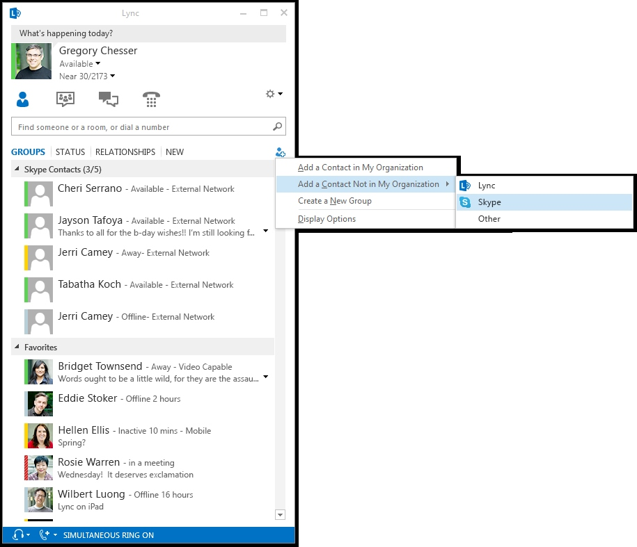

3. In the IM Address field, enter the Microsoft Account (MSA) of the Skype user.
4. In the Add to contact group dropdown box, select a contact group to add the user too.
5. In the Set privacy relationship dropdown box, select the appropriate contact setting and then click OK.

6. The user will now appear as a contact in Lync. Select the user, right-click the user name, and click See Contact Card to view the user properties. As shown below, you can also click Call then Lync Call to establish an audio call with the newly added Skype user.

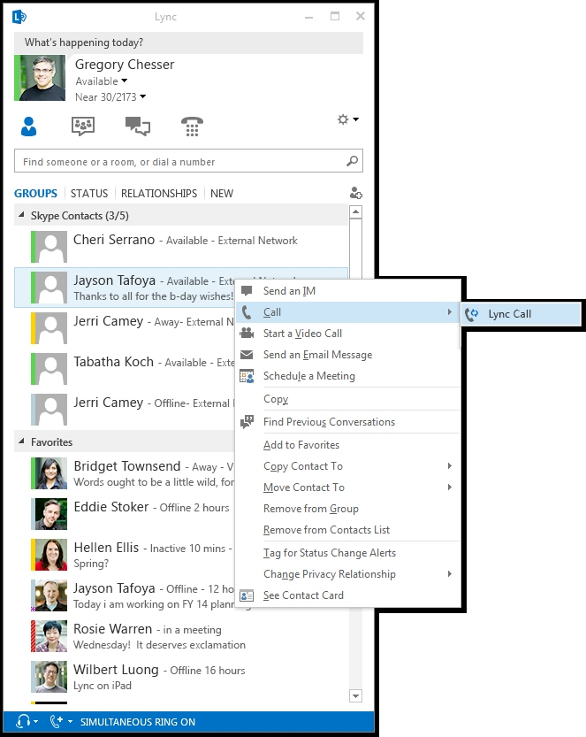

For additional information on support for contacts, see Add a contact in Lync and Adding an external contact in Lync

When a Skype user’s Microsoft account uses a custom domain name, such as bob@contoso.com, a Lync user can add that Microsoft account to Lync in two ways:
1. Use the Add a Contact icon.
2. Use the Find someone or a room, or a dial a number field.
In each instance, the Lync user must enter the Skype user’s email in the following format: user(domain name)@msn.com.
Important:
This step is not required for Microsoft accounts that use the following domain names: @live.com, @hotmail.com or @outlook.com. For more information on supported custom domain names, see Supported public IM domains.
To add a Skype contact to Lync when using a custom domain name
1. From Lync, click Add a Contact, Add a Contact Not in My Organization.
2. From the list of available contact providers, select Skype, as shown below.

3. In the IM Address field, enter the Microsoft Account (MSA) of the Skype user in the format user(domain name)@msn.com. So for user bob@contoso.com, the entry would be bob(contoso.com)@msn.com, as shown below.

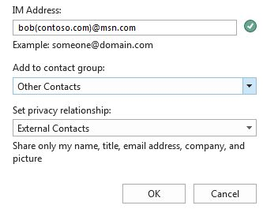

4. In the Add to contact group dropdown box, select a contact group to add the user too.
5. In the Set privacy relationship dropdown box, select the appropriate contact setting and then click OK.
6. A Lync user can also use the Find someone or a room, or dial a number field in Lync, and add an address that resembles the following user(domain name)@msn.com. So for the bob@contoso.com Microsoft account, the entry would be bob(contoso.com)@msn.com, as shown below.


7. Follow the remaining steps described previously to add the contact to a contact group and the set the privacy relationship.
To add a Lync contact to Skype
1. Sign in to Skype. The Skype user must be logged into their Skype client with a Microsoft Account (MSA).

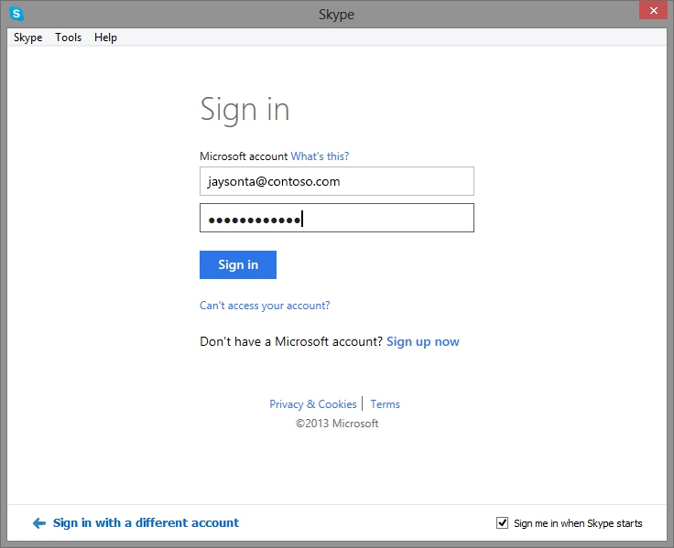

2. Select the Add Contacts icon.
3. Enter the SIP URI of the Lync user, for example, bob@contoso.com.
4. When Skype finds the match in the search results, notice the word Lync below the Lync user’s name. This indicates Skype successfully located the Lync client’s SIP URI. Click the name.

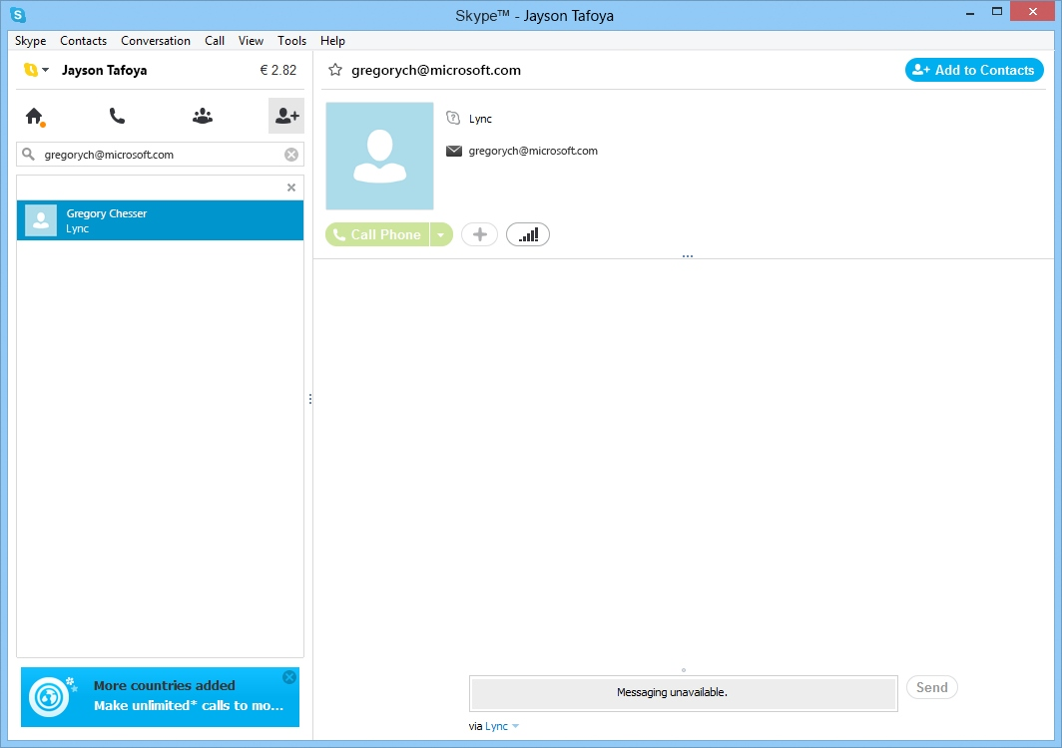

5. In the top right corner of the window, click Add to Contacts.
6. The new contact is now added to your contact list, but you’ll only see a question mark instead of their status icon until they accept your request. When your new contact accepts your request, you can see when they are online, initiate IM conversations, and make audio calls.

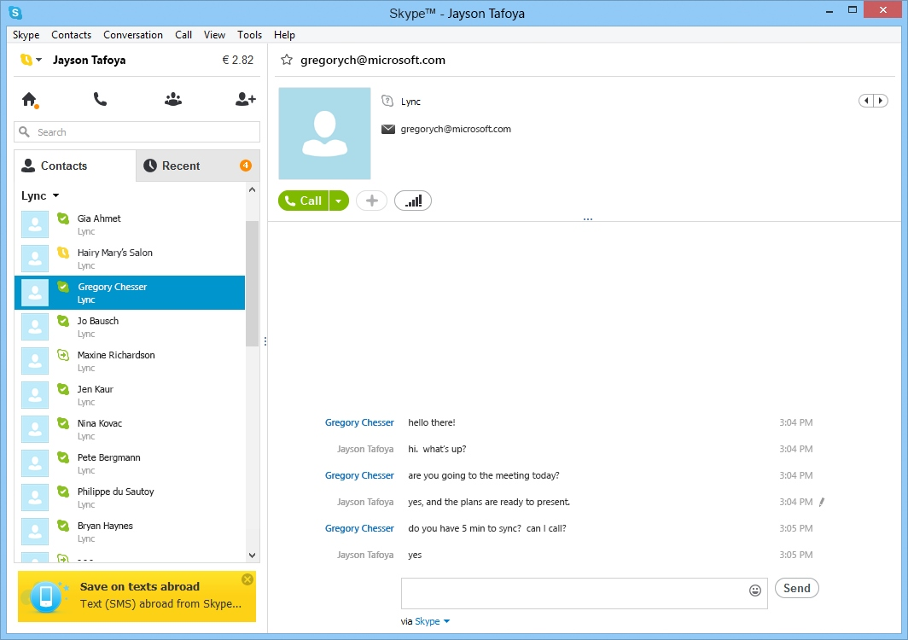

Important:
The Lync Server administrator must configure the Lync user’s policy settings to allow incoming requests. If not, the Lync user will not receive contact requests from the Skype user. Depending on the configuration of the Lync user’s policy settings, the request to add the Skype user will appear on the Lync client’s New tab. To begin communicating with the Skype user, the Lync user must add the Skype user to either the Favorites list or a contact list. The image below shows the location of the New tab in the Lync client.

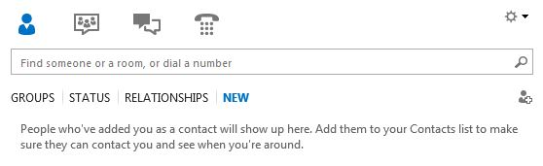

A Lync user must configure Lync alerts to ensure that requests sent from a Skype user appear and are discoverable by the Lync user. To configure Lync alerts, complete the procedure that follows.
To configure Lync Alerts
1. From the Lync client, click the Options icon.
2. Select Alerts.
3. Under General alerts, check Tell me when someone adds me to his or her contact list.
4. Under Contacts not using Lync, select Allow invites but block all other communications.
5. Click OK to close the Options window.



